**MASTER OF TECHNOLOGY**

**(INTELLIGENT SYSTEMS)**

**INSTALLATION & USER GUIDE**

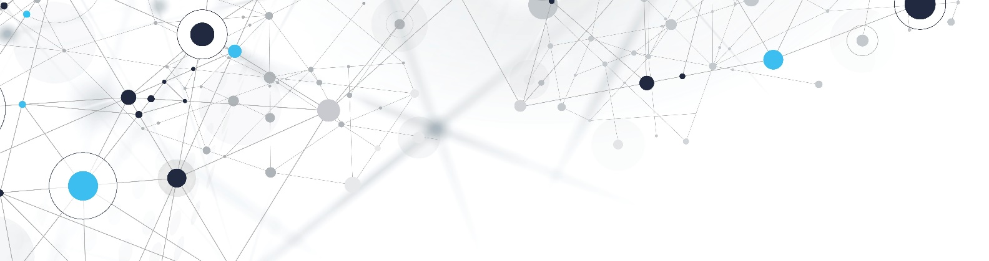

**Enterprise Knowledge Graph System**

(Knowledge Graph Solution that leads to Enterprise AI)

**GROUP MEMBERS**

YANG LU YI

YIN TIAN SHI

YU YU

MASTER OF TECHNOLOGY Institute of System Science, National University of Singapore

**Contents**

**1.0 System Overview 3**

**2.0 Installation 3**

**2.1 Recommended Browsers 3**

**2.2 Environment Requirement 3**

**2.3 Deployment 3**

**3.0 Web Settings & User Guide 5**

**3.1 Application Status & Settings 6**

**3.2 Graph Display Settings 6**

**3.3 Use Case #1 (360-degree Scan) 6**

**3.4 Use Case #2 (Relationship Scan) 8**

**3.5 Use Case #3 (End-to-End Process Scan) 9**

**3.6 Use Case #4 (Recommend Solution) 10**

**Appendix A – Deploy Dialogflow agent to new Google Cloud account 13**

# **System Overview**

The Enterprise Knowledge Graph System is an intelligent Web information system, which is designed to provide systematic and comprehensive representations of business structures. It is targeted to those internal stakeholders in enterprises, such as Enterprise Architects, Solution Designers, Business Analysts and staffs who are responsible for analysing and reasoning business operation process. Users can input keywords/ phrase to find out the optimized operation process and solution design strategies among the relationship of People, Process and Technologies.

# **Installation**

## **Recommended Browsers**

The system web UI supports the following Web browsers:

* Google Chrome Version 59 and above
* Microsoft Edge 44 and above
* Firefox 75 and above
* Safari Version 10 and above

## **Environment Requirement**

The system deploys to any environment having Docker Engine installed. Optionally, public internet connection is recommended, in order to support all functionalities in the system.

## **Deployment**

The system images are pulled from Docker Hub registry. In order to run the system, please ensure you have docker and docker-compose working on your laptop.

1. **Docker & Docker-Compose**
2. Download: <https://docs.docker.com/get-docker/>

*Note,* if you have already installed Oracle VM VirtualBox on laptop, please download Docker Desktop/ Toolbox: <https://docs.docker.com/toolbox/toolbox_install_windows/>

1. Verify it installed successfully:





1. Check what images include in Docker:



1. **Pull Docker Images and Start Application**
2. Download Docker Compose configuration (ekgs-compose.yml) to a local directory: <https://github.com/IRS-3Y/Enterprise-Knowledge-Graph-System/blob/master/SystemCode/ekgs-compose.yml>
3. (Optional) In case Dialogflow agent need be deployed to a new Google Cloud account, follow steps given in Appendix A and modify ekgs-compose.yml file accordingly before proceeding to next step.
4. Go to the local directory and execute the command on a terminal:

docker-compose -p ekgs -f ekgs-compose.yml up -d

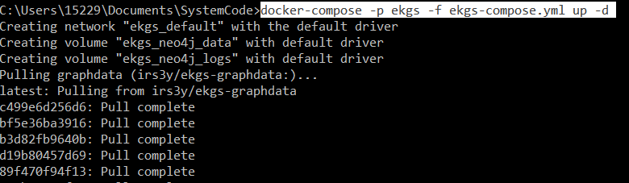

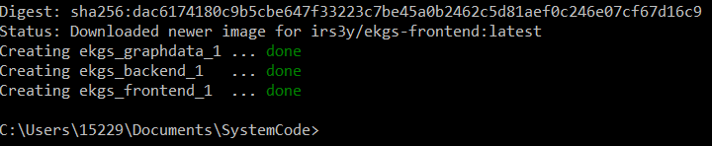

1. EKGS application is now running and available on [http://localhost](http://localhost/)

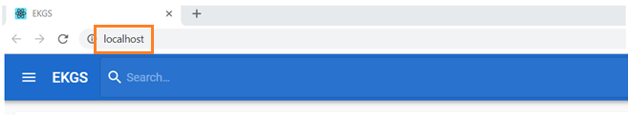

*Note*, if you installed Docker Toolbox, please execute the command on a terminal to get IP:

docker-machine ip

Then the application will show up on http://{DOCKER_HOST_IP}

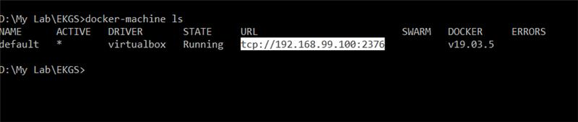

1. **Trouble-shoot Connection Problems**
2. Network ports occupied

For application to startup successfully, it requires port 80 and 7687 are not pre-occupied by other system processes. In case either port is occupied, you may change the port mapping by modifying ekgs-compose.yml file in text editor (before start application).

To change web UI port, update the mapping for port 80

e.g. “80:80” => “8080:80”, web UI will then be accessed via <http://localhost:8080>

To change Graph Data Service port, update the mapping for port 7687

e.g. “7687:7687” => “9687:7687”, after application startup, port 9687 should also be updated in Application Settings page (refer to section 3.1of this guide)

1. Dialogflow service disconnected

The system connects to Google Dialogflow service via public internet connection. In case it’s disconnected (and alert shown in landing page of web UI), check network settings of your laptop and Docker engine (especially when Docker is hosted in VM, check VM network settings as well).

1. **Stop Application**

Execute the command on a terminal to stop the application:

docker-compose -p ekgs -f ekgs-compose.yml down -v

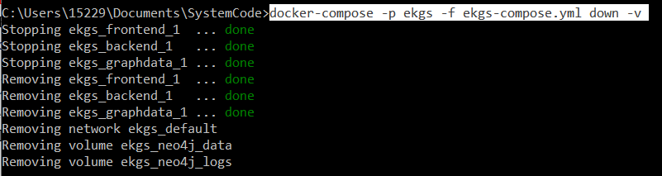

# **Web Settings & User Guide**

Open up your preferred browser and go to the URL “http://localhost” or “http://192.168.x.x” as shown below:

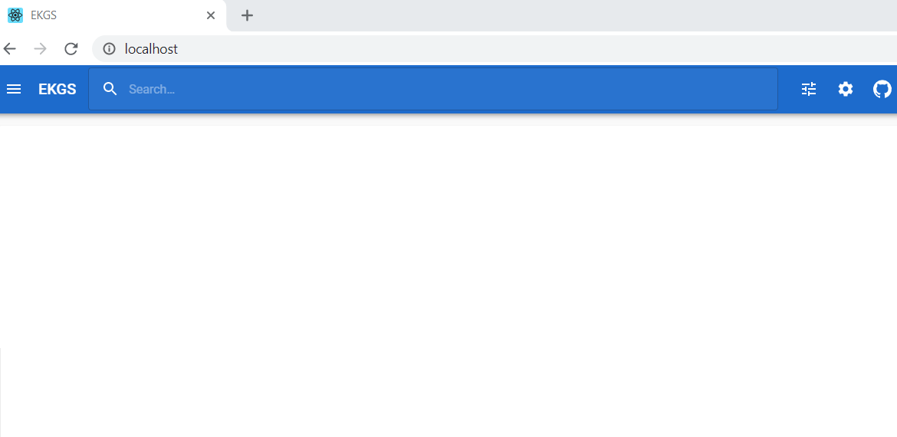

## **Application Status & Settings**

Application Status & Settings page can be accessed by clicking ‘settings’ icon on toolbar. Dialogflow status indicates connectivity to Google Cloud. Graph Data Service status indicates the readiness of data loading during system start. And its connection setting should be changed if port mapping is different in ekgs-compose.yml

## **Graph Display Settings**

As part of query result, the UI may render a Graph of nodes and relationships. To change displayed label in the Graph, update corresponding settings in the left-side menu.

## **Use Case #1 (360-degree Scan)**

We designed 4 different use cases, please follow the step-to-step guide below to understand how the system works.

*Tips:* can input the first letters of keywords to find out the following phrases.

* 360-degree Scan
* Relationship Scan
* End-to-End Process Scan
* Recommend Solution

1. Click Search bar, 4 use cases can be auto listed.

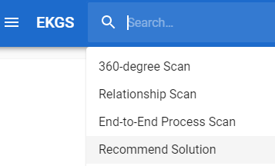

1. Select "360-degree Scan", the following phrase can be triggered accordingly.

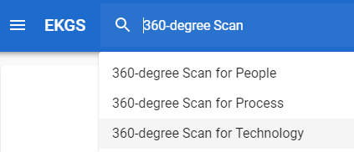

1. Select one of above phrases, such as "360-degree Scan for People", the following phrase can be triggered accordingly.

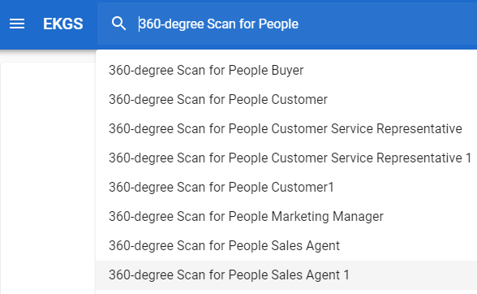

1. Continue to select one of above options, such as "360-degree Scan for People Marketing Manager", now the corresponding knowledge graph and brief text summary show up.

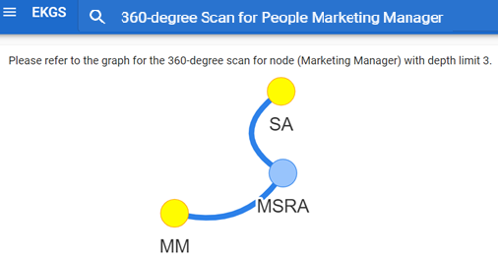

1. Click “X” cancel button to clear all inputs, then try to select other following options which you are interested in and have a look on the graph and text summary representation.

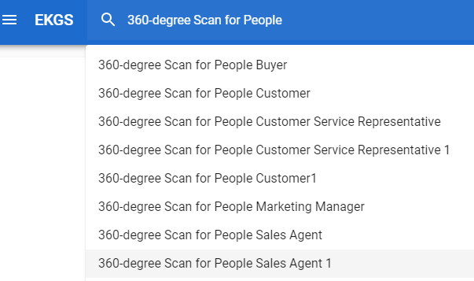

1. You may also try free-text input directly in search bar (subject to Dialogflow service connectivity). If the text matches a node name, it also triggers the 360-degree Scan action.

## **Use Case #2 (Relationship Scan)**

1. Select "Relationship Scan", the following phrase can be triggered accordingly. 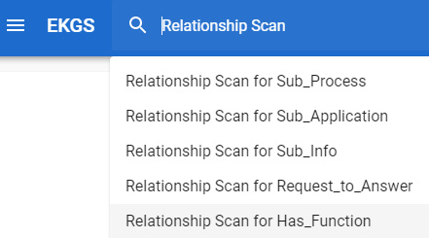
2. Continue to select one of above phrases, such as "Relationship Scan for Sub_Process", now the corresponding knowledge graph and brief text summary show up.

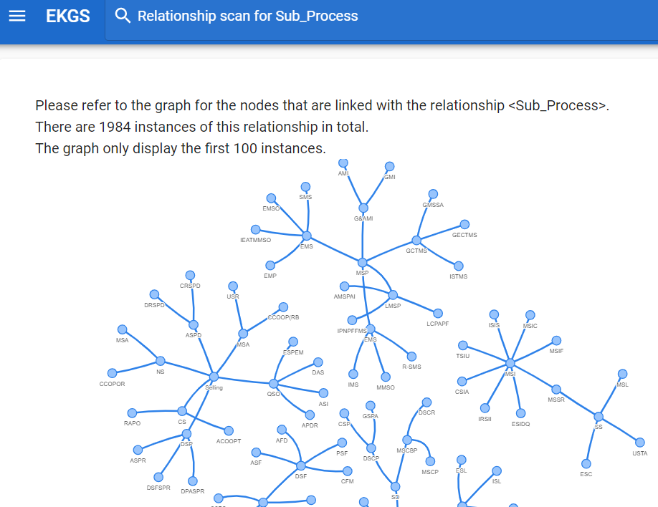

1. Click “X” cancel button to clear all inputs, then try to select other following options which you are interested in and have a look on the graph and text summary representation.

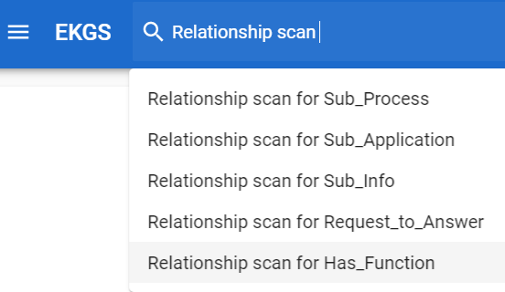

1. You may also try free-text input directly in search bar (subject to Dialogflow service connectivity). If the text has keyword ‘relationship’ and matches a relationship type, it also triggers Relationship Scan action.

## **Use Case #3 (End-to-End Process Scan)**

1. Select "End-to-End Process Scan", the following phrase can be triggered accordingly.

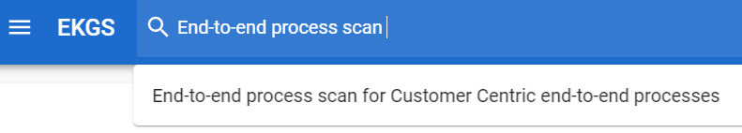

1. Continue to select the phrase "End-to-End Process Scan for Customer Centric End-to-End Processes", now the corresponding knowledge graph and brief text summary show up.

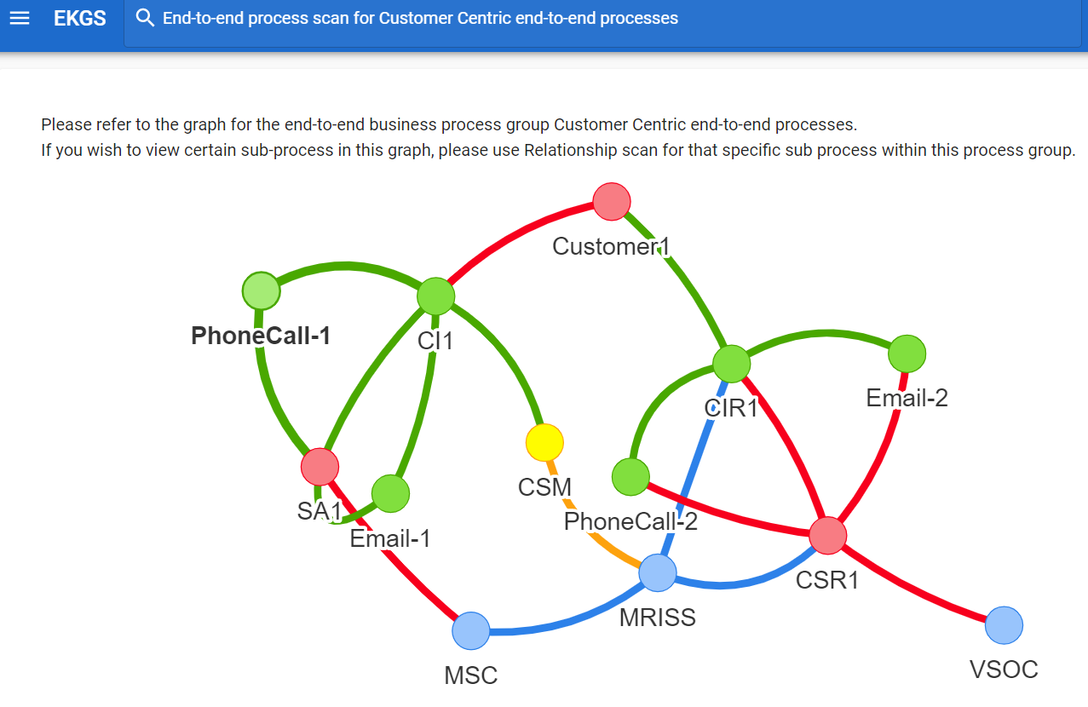

1. You may also try free-text input directly in search bar (subject to Dialogflow service connectivity). If the text has keyword ‘process’ and matches a process stream name, it also triggers End-to-End Process Scan action.

## **Use Case #4 (Recommend Solution)**

1. Select "Recommend Solution", the following phrase can be triggered accordingly.

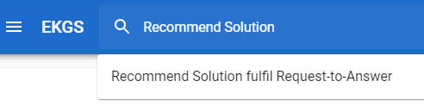

1. Select the phrase "Recommend Solution fulfil Request-to-Answer", the following phrase can be triggered accordingly.

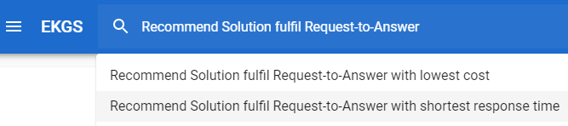

1. Continue to select 1st above option " Recommend Solution fulfil Request-to-Answer with Lowest Cost", now the corresponding knowledge graph and brief text summary show up.

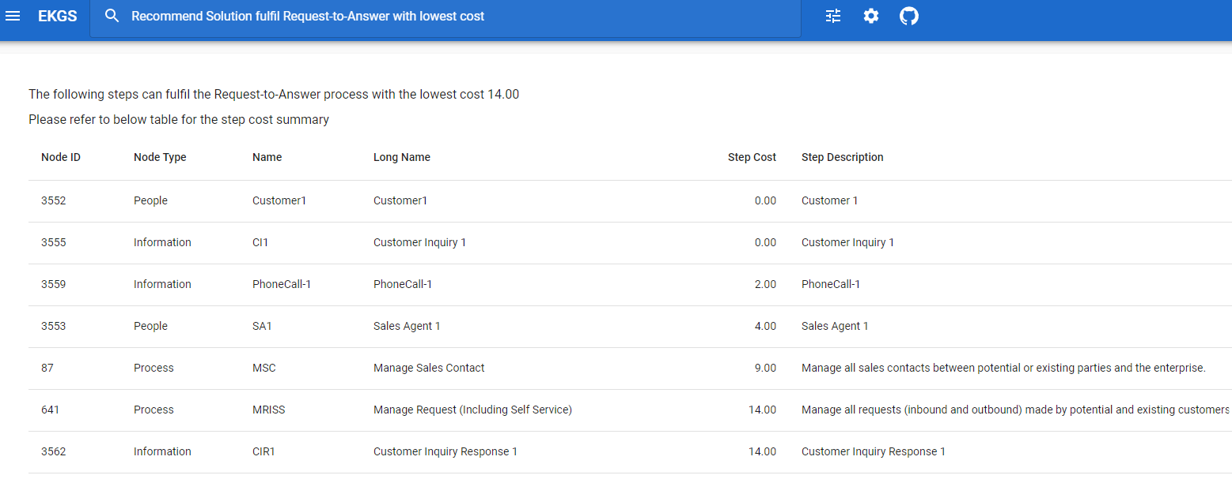

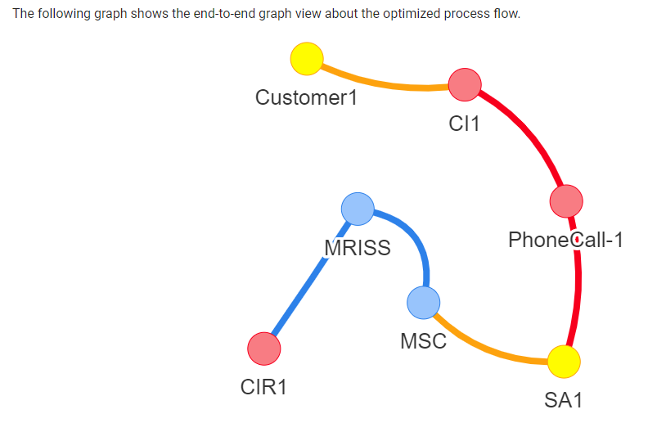

1. Try to select 2nd above option "Recommend Solution fulfil Request-to-Answer with shortest response time", now the corresponding knowledge graph and brief text summary show up.

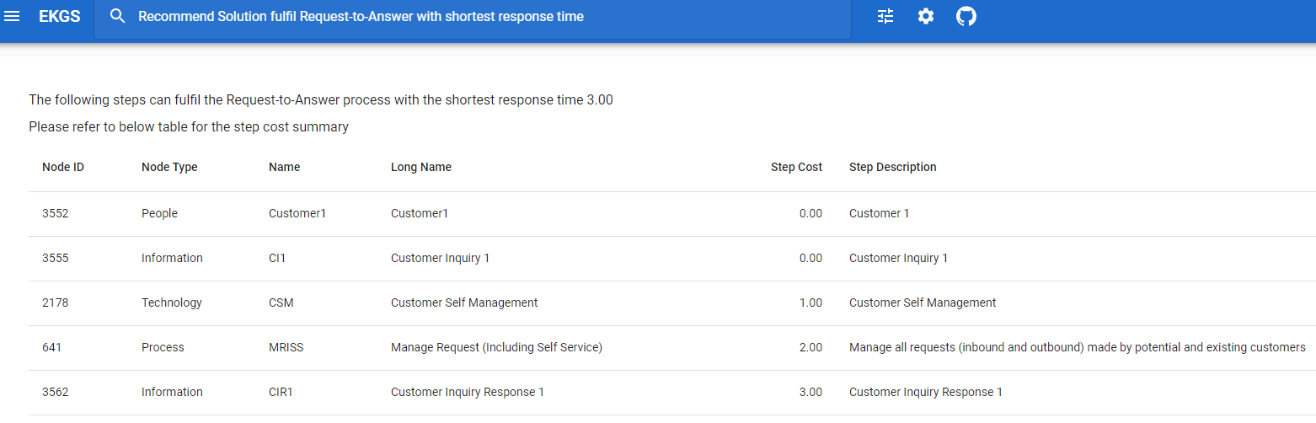

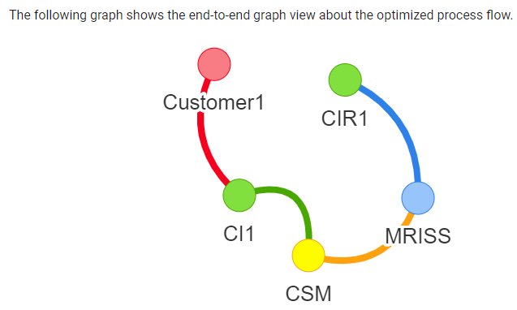

1. To change resource settings and simulate transaction load in process stream, click the ‘resource simulation’ icon in toolbar and modify those settings in the simulation page.

## **Appendix A – Deploy Dialogflow agent to new Google Cloud account**

EKGS application has default configuration to connect with a pre-deployed Dialogflow agent, so that it works out-of-box without any Dialogflow deployment being performed by the user. However, in situation whereby the agent should be re-deployed to a new Google Cloud account, follow below steps to deploy it, export service account key and configure EKGS Docker Compose file.

1. Download the Dialogflow agent ZIP from our GitHub repository’s “Miscellaneous” folder. <https://github.com/IRS-3Y/Enterprise-Knowledge-Graph-System/blob/master/Miscellaneous/Dialogflow-Agent-EkgsBot.zip>
2. Go to the project settings of the target Dialogflow project (created with your own Google account). Under “Export and Import” tab, click “Restore from ZIP” button and select the agent file downloaded in previous step.

1. From project settings “General” tab, click “Service Account” link to open Google Cloud project’s setting page.

1. Click “Create Service Account” button.

1. Fill in account details based on your own preferences and create the account. In the second page “Service account permissions”, select “Dialogflow API Client” role for this account.

1. Once created, the new service account appears in your project’s “Service Accounts” list. Click the new service account’s name for adding key to it.

1. Select “JSON” as key type and click “Create”. It will prompt to download the key file. Save it to your local machine (e.g. <DownloadFolder>/your-project-key.json)

1. Use below shell commands to create a Docker volume holding the service account key file (JSON file saved in previous step <DownloadFolder>).

docker volume create ekgs_config

docker run -d --rm --name dummy -v ekgs_config:/root alpine tail -f /dev/null

docker cp <DownloadFolder>/your-project-key.json dummy:/root/ your-project-key.json

docker stop dummy

1. Update ekgs-compose.yml volume mapping and environment variable to use the new service account key. Edit lines highlighted below.

volumes:

ekgs_config:

external: **true**

services:

backend:

environment:

- "GOOGLE_APPLICATION_CREDENTIALS=**/ekgs-config/your-project-key.json**"